High-Performance Text Searching for Electronic Health Records
Project Report submitted for the partial fulfilment of grade for the course

Data Structures and Algorithms -3 (25CS2103E)
in

A.Y. 2026-2027

Submitted by
Vaishali (2520030117)
Bindhu Madhavi (2520030077)
Sri Kruthi (2520030340)

Team Number:
Section:

Under the guidance of

S. Madhavi

<<Designation, Department>>
Hyderabad-500090, Telangana, India.

K L (Deemed to be) University
DEPARTMENT OF COMPUTER SCIENCE ENGINEERING / COMPUTER SCIENCE AND INFORMATION TECHNOLOGY/ARTIFICIAL INTELLIGENCE & DATA SCIENCE



DECLARATION

The Mini Project Report entitled “High-Performance Text Searching for Electronic Health Records” is a record of Bonafide work of Vaishali – 2520030117, Bindhu Madhavi – 2520030077, Sri Kruthi – 2520030340 submitted in partial fulfillment for the award of B. Tech in Computer Science and Engineering/Computer Science and Information Technology/ Artifical Intelligence & data Science to the K L University. The results embodied in this report have not been copied from any other departments/University/Institute.

Vaishali – 2520030117
Bindhu Madhavi – 2520030077
Sri Kruthi – 2520030340

K L (Deemed to be) University
DEPARTMENT OF COMPUTER SCIENCE ENGINEERING / COMPUTER SCIENCE AND INFORMATION TECHNOLOGY
CERTIFICATE

This is to certify that the mini project based report entitled “High-Performance Text Searching for Electronic Health Records” is a bonafide work done and submitted by Vaishali – 2520030117, Bindhu Madhavi – 2520030077, Sri Kruthi – 2520030340 in partial fulfillment of the requirements for the award of the degree of BACHELOR OF TECHNOLOGY in Department of Computer Science Engineering/ Computer Science and Information Technology/Artificial Intelligence & Data Science, K L (Deemed to be University), during the academic year 2026-2027.

Signature of the Supervisor

Signature of the HOD Signature of the External Examiner

ACKNOWLEDGEMENT

The success in this project would not have been possible but for the timely help and guidance rendered by many people. Our wish to express my sincere thanks to all those who has assisted us in one way or the other for the completion of my project.

Our greatest appreciation to my guide, S. Madhavi, <<Designation>>, <<Department>> which cannot be expressed in words for his/her tremendous support, encouragement and guidance for this project.

We express our gratitude to Dr. P.Venkateshwar Rao (CSE)/Dr. Khaja Shareef (CSIT)/ Dr. Sreenath Itikela (AI&DS), Head of the Department for Computer Science Engineering/ Department for Computer Science and Information Technology/Department of Artificial Intelligence and Data Science for providing us with adequate facilities, ways and means by which we are able to complete this project-based Lab.

We thank all the members of teaching and non-teaching staff members, and also who have assisted me directly or indirectly for successful completion of this project. Finally, I sincerely thank my parents, friends and classmates for their kind help and cooperation during my work.

Vaishali – 2520030117
Bindhu Madhavi – 2520030077
Sri Kruthi – 2520030340

TABLE OF CONTENTS

S.No. | Contents | Page no.
1. | Abstract | 6
2. | Introduction | 7
3. | Literature survey | 7
4. | Problem Statement and Objectives | 9
5. | Hardware and Software requirements | 10
6. | Implementation | 10
7. | Results & Discussion | 15
8. | Conclusion & Future Scope | 18
9. | References | 19

1.ABSTRACT
Electronic Health Records (EHRs) store large amounts of free-text clinical information such as symptoms, diagnoses and doctors’ notes, and clinicians need to retrieve matching patient records quickly. This project presents High-Performance Text Searching for Electronic Health Records, a browser-based search system built with HTML, CSS and JavaScript. It searches a collection of 200 synthetic patient records (PAT-0001 to PAT-0200) for a symptom or diagnosis word such as fever, cough, cold or migraine. Ten algorithms are provided in one interface: Linear Search, Naive String Search, KMP, Z-Function, Rabin-Karp, Hashing Search, DP on Trees, DP on Subset, Ford-Fulkerson with Edmonds-Karp and Maximum Flow. The user selects an algorithm, enters a word and runs the search. The system lists the matching records with the word highlighted, reports the records shown, the records checked and the time taken in milliseconds, and prints a step-by-step log that explains how the chosen algorithm works. Naive, KMP, Z-Function and Rabin-Karp perform true pattern matching on the symptom and note text of each record, while the other algorithms are demonstrated through their working steps. In testing, all ten algorithms returned the same results: 80 records for fever, 100 for cough, 40 for cold and 20 for migraine. The system shows how data-structure and algorithm techniques can support fast medical information retrieval.
Team Name:
Team Logo (if any):
Team Members:
- Vaishali, 2520030117
- Bindhu Madhavi, 2520030077
- Sri Kruthi, 2520030340

- INTRODUCTION
Hospitals and clinics now keep patient information in Electronic Health Records (EHRs). A large part of this information is unstructured text, for example the symptoms recorded at a visit and the doctor’s notes. As the number of records grows, finding every patient who reports a particular symptom or diagnosis by reading the records one by one becomes slow and error-prone. Efficient text-searching algorithms are therefore an important part of any health information system.
This project, High-Performance Text Searching for Electronic Health Records, builds a web-based tool that retrieves matching patient records from a collection of 200 synthetic records. Each record has an ID (PAT-0001 to PAT-0200), an age between 18 and 80, a list of symptoms and a short diagnosis note, and the records are generated from ten symptom-and-note templates. The motivation is to study how string-matching algorithms such as Naive, KMP, Z-Function and Rabin-Karp differ from simple scanning, and to present hashing, dynamic programming and network-flow ideas in the same search workflow so that ten algorithms of the course Data Structures and Algorithms-3 can be compared on the same data.
The user chooses an algorithm, types a word and presses Run search. The system then displays the matching records with the word highlighted, the number of records shown and checked, the time taken in milliseconds and a step-by-step explanation of the algorithm. The rest of this report is organised as follows: Section 3 reviews related work, Section 4 states the problem and objectives, Section 5 lists the hardware and software requirements, Section 6 presents the implementation, Section 7 discusses the results, Section 8 gives the conclusion and future scope, and Section 9 lists the references.
- LITERATURE SURVEY
The following existing algorithms, books and systems were studied for this project. The numbers in square brackets refer to the References section.
1. Knuth–Morris–Pratt (KMP) algorithm. Knuth, Morris and Pratt introduced a linear-time string-matching method that builds a prefix (LPS) table for the pattern so that the search never moves backwards in the text [1]. It runs in O(n + m) time and is the basis of the KMP search used in this project. A worked explanation with code is given in [9].
2. Z-function. The Z-function stores, for every position of a string, the length of the longest substring starting there that matches the prefix of the string [6]. By joining the pattern, a separator and the text, every occurrence of the pattern can be found in O(n + m) time. This project uses the same pattern + “$” + text method; see [10].
3. Rabin–Karp algorithm. Karp and Rabin proposed comparing the hash value of the pattern with the hash value of every window of the text, where the window hash is updated by a rolling computation [2]. The average running time is O(n + m) and the method extends easily to many patterns [12]. The project uses base 256 and prime 101.
4. Naive and linear search. The naive method tries the pattern at every position of the text and needs O(n·m) time in the worst case, while linear search checks every record one by one. Both are simple baselines against which the faster algorithms are compared [5], [11].
5. Hash-based search. A hash table maps a key to a hash value so that a lookup takes O(1) time on average [13]. Hash values are also the main idea behind Rabin–Karp. The project’s Hashing Search computes and displays the polynomial hash of the search word.
6. Dynamic programming on trees and subsets. Dynamic programming solves a problem by storing and combining the answers of overlapping sub-problems [5], [14]. In DP on trees the values are computed from the leaves upward, and in DP on subsets a table is built over the subsets of a small set of items. Both are demonstrated step by step in this project.
7. Ford–Fulkerson and Edmonds–Karp maximum flow. Ford and Fulkerson computed the maximum flow of a network by repeatedly finding augmenting paths [3]. Edmonds and Karp chose the shortest augmenting path by breadth-first search, which gives O(V·E²) time [4], [15]. The project demonstrates this on a small network whose maximum flow is 18.
8. EMERSE – Electronic Medical Record Search Engine. EMERSE, developed by Hanauer at the University of Michigan, is a search engine for the free-text documents of electronic medical records and is used for research and data abstraction [7], [8]. It shows the real need for fast keyword search over clinical text, which this project demonstrates on a small scale with several algorithms.
Unlike the above sources, which describe a single algorithm or a large clinical system, this project brings ten algorithms into one interactive search page for health records and shows the time, the number of records and the working steps for each of them.
- Problem Statement and Objectives
Problem Statement:
Fast and accurate keyword search over free-text patient health records.
Problem Description:
Scanning free-text health records one by one becomes slow as the data grows, and it is not obvious which search algorithm suits the task best. This project builds a 200-record search system that runs ten algorithms on the same data and shows the matching records, the time taken and the steps of each algorithm.
Purpose of the project:
The project was started to give clinicians and students a simple tool for finding patient records by symptom or diagnosis, and to compare how different algorithms perform this task on the same data.
Objectives:
- To build a web application that searches 200 patient records by a symptom or diagnosis word.
- To implement the Naive, KMP, Z-Function and Rabin-Karp string-matching algorithms and apply them to the symptom and note text of every record.
- To provide Linear Search and Hashing Search as baseline methods, and to demonstrate DP on Trees, DP on Subset, Ford-Fulkerson with Edmonds-Karp and Maximum Flow in the same interface.
- To display the matching records with the searched word highlighted.
- To report the records shown, the records checked and the time taken in milliseconds.
- To show a step-by-step log that explains how the selected algorithm works.
- HARDWARE AND SOFTWARE REQUIREMENTS
Hardware Requirements:
- Processor: Intel Core i3 / AMD Ryzen 3 or higher (dual core, 2 GHz or above)
- RAM: 4 GB minimum (8 GB recommended)
- Storage and display: 100 MB free disk space; screen resolution 1366 × 768 or higher
Software Requirements:
- Operating system: Windows 10/11, Linux or macOS
- Web browser: latest Google Chrome, Microsoft Edge or Mozilla Firefox (BigInt support is needed for Hashing Search)
- Languages: HTML5, CSS3 and JavaScript (ES2020)
- Editor: Visual Studio Code or any text editor
- IMPLEMENTATION
The system is a single HTML file written in HTML5, CSS3 and JavaScript. The user-interface markup and styling are not repeated here; the four JavaScript modules below contain the logic of the project. Table 6.1 lists the ten algorithms offered by the application.
Table 6.1: Algorithms implemented in the application
No. | Algorithm | Technique | Time complexity | Role in this project
1 | Linear Search | Scan every record in order | O(N) | Baseline matcher (substring check)
2 | Naive String Search | Try the pattern at every position | O(n·m) | Pattern matching on symptoms and note
3 | KMP String Search | LPS (prefix) table | O(n + m) | Pattern matching on symptoms and note
4 | Z-Function | Z-array of pattern + $ + text | O(n + m) | Pattern matching on symptoms and note
5 | Rabin-Karp | Rolling hash (base 256, prime 101) | O(n + m) avg. | Pattern matching on symptoms and note
6 | Hashing Search | Polynomial hash (base 31) | O(m) to hash | Hash value shown; substring check
7 | DP on Trees | Bottom-up DP from the leaves | O(N) | Steps shown; substring check
8 | DP on Subset | DP table over a subset | O(2^k) | Steps shown; substring check
9 | Ford-Fulkerson with Edmonds-Karp | BFS augmenting paths | O(V·E²) | Steps shown (max flow 18); substring check
10 | Maximum Flow | Source-to-sink flow | O(V·E²) | Steps shown (max flow 18); substring check

Module 1: Data Generation
This module defines the ten symptom-and-note templates (T) and generates 200 synthetic patient records. Record number i receives the ID PAT-000i, an age from 18 to 80 and template i mod 10.
// Module 1: Data generation - 200 synthetic patient records
const TOTAL = 200;
const T = [
["Fever, Cough, Headache, Fatigue", "Fever, cough and acute respiratory infection syndrome"],
["Cough, Cold, Sore Throat", "Common cold with mild respiratory symptoms"],
["Headache, Nausea, Dizziness", "Migraine related headache and dizziness"],
["Fever, Body Pain, Weakness", "Viral fever with body pain and weakness"],
["Stomach Pain, Vomiting", "Gastric infection with abdominal discomfort"],
["Cough, Breathing Difficulty", "Respiratory infection with breathing difficulty"],
["Back Pain, Joint Pain", "Musculoskeletal pain requiring observation"],
["Fever, Headache, Cough", "Flu symptoms with fever and headache"],
["Fatigue, Weakness, Headache", "General fatigue and weakness"],
["Cold, Cough, Fever", "Upper respiratory tract infection"]
];
const recs = Array.from({ length: TOTAL }, (_, i) => ({
id: "PAT-" + String(i + 1).padStart(4, "0"),
age: 18 + (i % 63),
sym: T[i % 10][0],
note: T[i % 10][1]
}));

Module 2: String-Matching Algorithms
This module contains the four real pattern-matching algorithms: Naive search, KMP with its LPS table, the Z-function and Rabin-Karp with a rolling hash. Each function takes a text t and a pattern p and returns true when p occurs in t.
// Module 2: String-matching algorithms (text t, pattern p)

// Naive: try the pattern at every position of the text
const naive = (t, p) => {
if (!p) return true;
for (let i = 0; i <= t.length - p.length; i++) {
let j = 0;
while (j < p.length && t[i + j] === p[j]) j++;
if (j === p.length) return true;
}
return false;
};

// KMP: LPS (longest proper prefix which is also a suffix) table
const lpsOf = p => {
const l = [0];
let len = 0, i = 1;
while (i < p.length) {
if (p[i] === p[len]) { l[i++] = ++len; }
else if (len) len = l[len - 1];
else l[i++] = 0;
}
return l;
};
const kmp = (t, p) => {
if (!p) return true;
const l = lpsOf(p);
let i = 0, j = 0;
while (i < t.length) {
if (t[i] === p[j]) {
i++; j++;
if (j === p.length) return true;
} else if (j) j = l[j - 1];
else i++;
}
return false;
};

// Z-Function: Z[i] = longest match of s[i..] with the prefix of s
const zArr = s => {
const n = s.length, z = Array(n).fill(0);
let L = 0, R = 0;
for (let i = 1; i < n; i++) {
if (i <= R) z[i] = Math.min(R - i + 1, z[i - L]);
while (i + z[i] < n && s[z[i]] === s[i + z[i]]) z[i]++;
if (i + z[i] - 1 > R) { L = i; R = i + z[i] - 1; }
}
return z;
};
const zs = (t, p) => {
if (!p) return true;
const z = zArr(p + "$" + t);
for (let i = p.length + 1; i < z.length; i++)
if (z[i] === p.length) return true;
return false;
};

// Rabin-Karp: rolling hash (base 256, prime 101)
const rk = (t, p) => {
const n = t.length, m = p.length;
if (!m) return true;
if (m > n) return false;
const B = 256, P = 101;
let ph = 0, th = 0, pw = 1;
for (let i = 0; i < m - 1; i++) pw = pw * B % P;
for (let i = 0; i < m; i++) {
ph = (B * ph + p.charCodeAt(i)) % P;
th = (B * th + t.charCodeAt(i)) % P;
}
for (let i = 0; i <= n - m; i++) {
if (ph === th && t.substr(i, m) === p) return true;
if (i < n - m) {
th = (B * (th - t.charCodeAt(i) * pw) + t.charCodeAt(i + m)) % P;
if (th < 0) th += P;
}
}
return false;
};

Module 3: Matchers and Algorithm Registry
This module defines the hash function used by Hashing Search, the substring matcher used by the baseline and demonstration algorithms, and the registry ALG of all ten algorithms with their names, matchers and step-by-step explanations.
// Module 3: Matchers and algorithm registry
const hf = s => { // polynomial hash of the word (base 31)
let h = 0n;
for (const c of s) h = h * 31n + BigInt(c.charCodeAt(0));
return h;
};
const contains = (r, w) =>
(r.sym + " " + r.note).toLowerCase().includes(w) ||
r.sym.toLowerCase().includes(w) ||
r.note.toLowerCase().includes(w);
const both = f => (r, w) =>
f(r.sym.toLowerCase(), w) || f(r.note.toLowerCase(), w);

const ALG = {
linear: { name: "Linear Search", m: contains,
steps: w => ["Search word = " + w, "Start from the first record.",
"Compare records one by one."] },
naive: { name: "Naive String Search", m: both(naive),
steps: w => ["Pattern = " + w,
"Compare the pattern at every position of each record."] },
kmp: { name: "KMP String Search", m: both(kmp),
steps: w => { const l = lpsOf(w);
return ["Pattern = " + w,
"Build the LPS array so mismatches never move backwards in the text.",
"Pattern: " + [...w].join(" "), "LPS: " + l.join(" ")]; } },
z: { name: "Z-Function", m: both(zs),
steps: w => ["Pattern = " + w,
"Join pattern + $ + record, then compute Z values.",
"A Z value equal to the pattern length means a match."] },
rk: { name: "Rabin-Karp", m: both(rk),
steps: w => ["Pattern = " + w,
"Compute the pattern hash (base 256, prime 101).",
"Slide a rolling hash along each record.",
"Verify character by character only when hashes agree."] },
hash: { name: "Hashing Search", m: contains,
steps: w => ["Search word = " + w, "Hash value = " + hf(w).toString()] },
tree: { name: "DP on Trees", m: contains,
steps: w => ["Search word = " + w,
"Records are grouped under a tree: root, left/right, leaves R1-R4.",
"DP values are computed from the leaves upward: DP[1..7] = 1..7."] },
subset: { name: "DP on Subset", m: contains,
steps: w => ["Search word = " + w, "Subset = 1 2 3 4 5",
"DP table initialised for 200 records; matching records are marked true."] },
ff: { name: "Ford-Fulkerson with Edmonds-Karp", m: contains,
steps: w => ["Search word = " + w,
"Flow network: S->A 10, S->B 10, A->T 8, B->T 10.",
"BFS path 1: S -> A -> T, bottleneck 8.",
"BFS path 2: S -> B -> T, bottleneck 10.",
"8 + 10 = 18", "MAXIMUM FLOW = 18"] },
flow: { name: "Maximum Flow", m: contains,
steps: w => ["Search word = " + w, "Source = S, Sink = T.",
"S -> A -> T carries 8.", "S -> B -> T carries 10.",
"8 + 10 = 18", "MAXIMUM FLOW = 18"] }
};

Module 4: Search Controller and Result Display
This module reads the word and the selected algorithm, filters the 200 records, measures the time, prints the step log and draws the matching records with the first occurrence of the word highlighted.
// Module 4: Search controller and result display
const $ = id => document.getElementById(id);
const esc = s => s.replace(/[&<>]/g,
c => ({ "&": "&amp;", "<": "&lt;", ">": "&gt;" }[c]));

function hl(s, w) { // highlight first occurrence of w
if (!w) return esc(s);
const i = s.toLowerCase().indexOf(w);
return i < 0 ? esc(s)
: esc(s.slice(0, i)) + "<mark>" + esc(s.slice(i, i + w.length)) +
"</mark>" + esc(s.slice(i + w.length));
}

function draw(list, w, hit) { // render record cards
$("list").innerHTML = list.map(r =>
`<div class="rec${hit ? " hit" : ""}"><b>${r.id}</b> <small>age ${r.age}</small><br>` +
`${hl(r.sym, w)}<br><small>${hl(r.note, w)}</small></div>`).join("");
$("sCount").textContent = list.length;
}

function run() { // executed on "Run search"
const w = $("word").value.trim().toLowerCase();
const a = ALG[$("algo").value];
const t0 = performance.now();
const out = recs.filter(r => a.m(r, w));
const ms = (performance.now() - t0).toFixed(2);
$("sCmp").textContent = TOTAL;
$("sTime").textContent = ms;
const lines = a.steps(w).map((s, i) => "Step " + (i + 1) + ": " + s);
lines.unshift(a.name.toUpperCase());
lines.push(out.length ? "Done. Total matching records = " + out.length
: "Done. No record found for word: " + w);
$("log").textContent = lines.join("\n");
draw(out, w, true);
}
$("go").onclick = run;
$("word").addEventListener("keydown", e => { if (e.key === "Enter") run(); });

- RESULTS & DISCUSSION
The application was run on the 200 synthetic patient records. Figures 7.1 to 7.5 show the output screens of the system and Table 7.1 summarises the matching counts obtained for five search words.
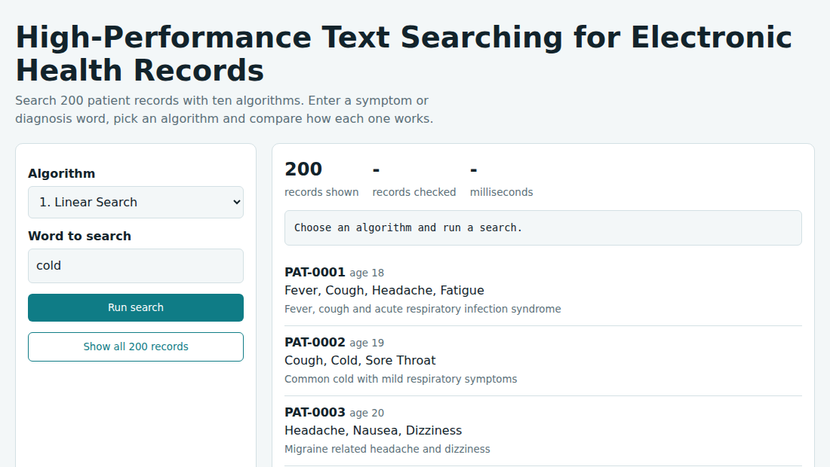
Fig. 7.1: Home screen of the application
The home screen shows the drop-down with the ten algorithms, the word box (default “cold”) and all 200 records. The panel on the right shows 200 records shown before any search is run.
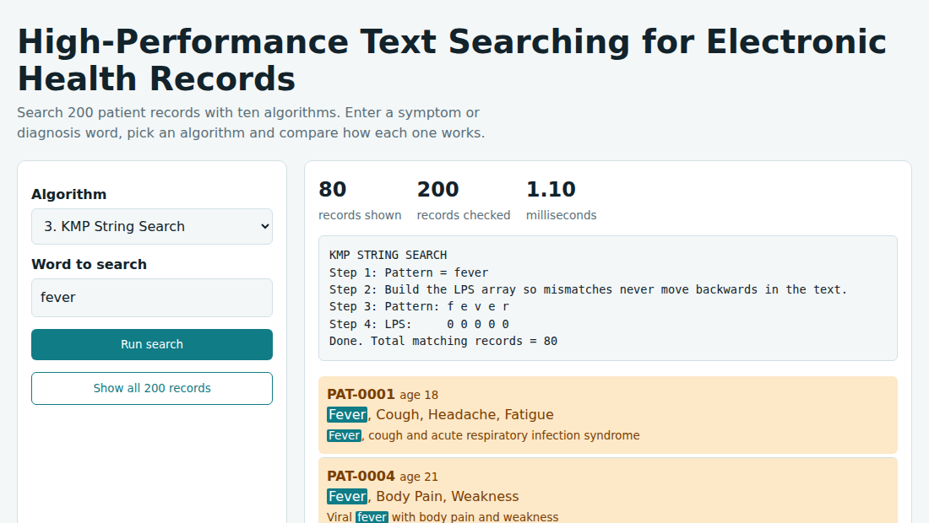
Fig. 7.2: KMP String Search for the word “fever”
The log shows the pattern, the LPS array (0 0 0 0 0) and the message “Total matching records = 80”. The word fever is highlighted in the symptoms and the note of each record.
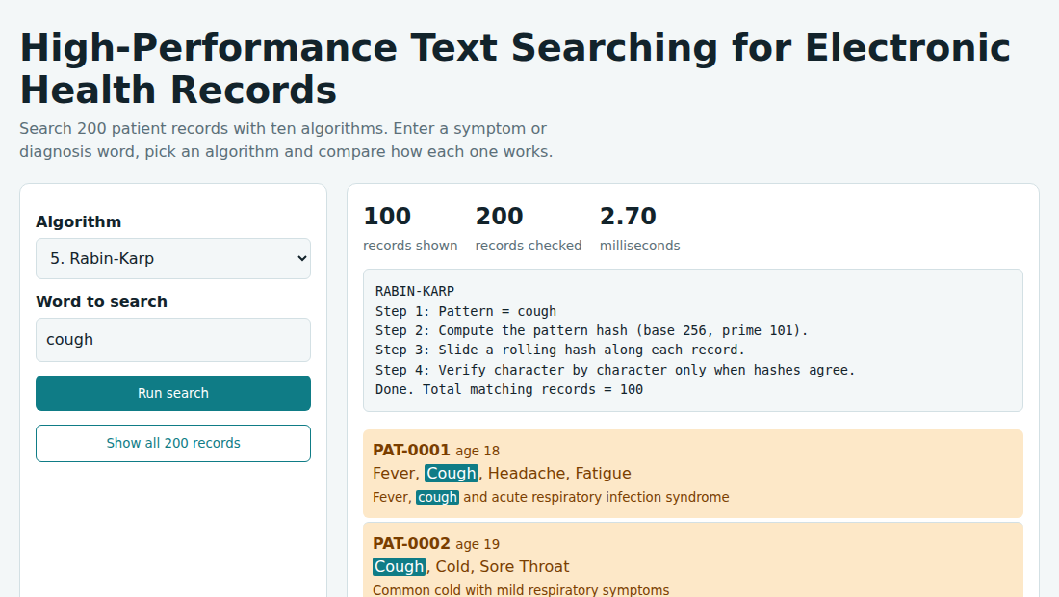
Fig. 7.3: Rabin-Karp search for the word “cough”
The log explains the base-256, prime-101 rolling hash and the character-by-character check when hashes agree. The search returns 100 matching records out of 200 checked.
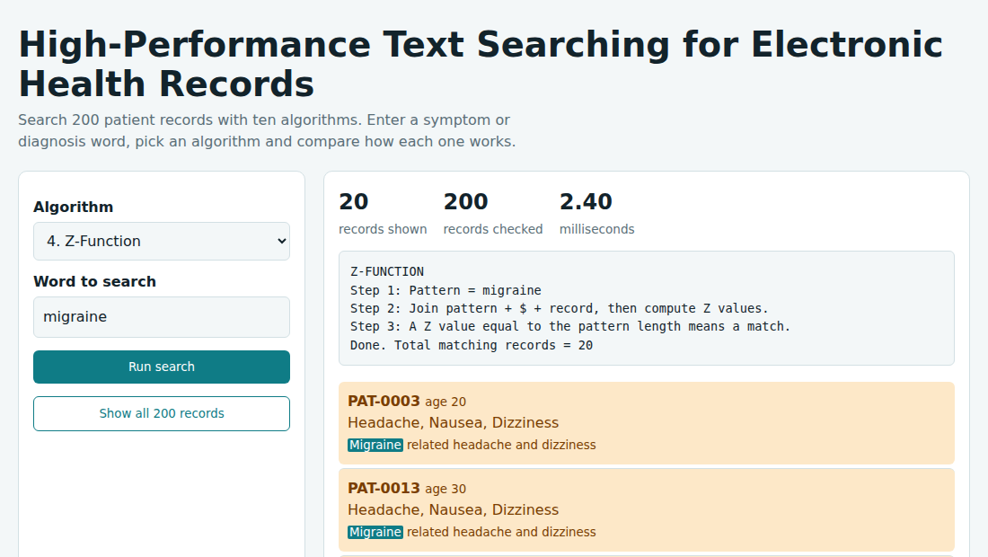
Fig. 7.4: Z-Function search for the word “migraine”
The pattern, “$” and the record are joined and the Z values are computed; a Z value equal to the pattern length is a match. Only 20 records contain the word migraine.
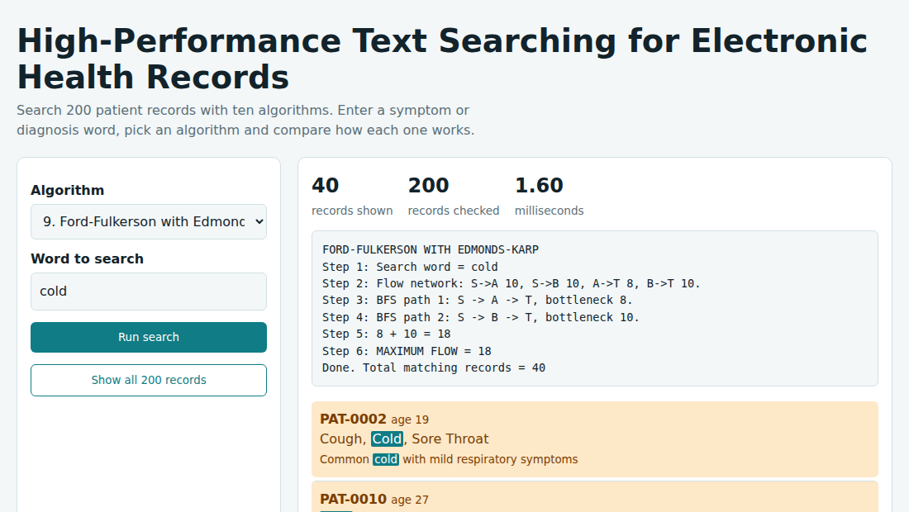
Fig. 7.5: Ford-Fulkerson with Edmonds-Karp for the word “cold”
The log shows the flow network, the two BFS augmenting paths (8 and 10) and MAXIMUM FLOW = 18. The search itself returns 40 records containing the word cold.
Table 7.1: Matching records for different search words
Search word | Matching records | Share of 200 records | Same count in all 10 algorithms
fever | 80 | 40% | Yes
cough | 100 | 50% | Yes
cold | 40 | 20% | Yes
migraine | 20 | 10% | Yes
headache | 80 | 40% | Yes
Discussion
Correctness: for every search word tested, all ten algorithms returned exactly the same number of records (Table 7.1). This confirms that the Naive, KMP, Z-Function and Rabin-Karp implementations agree with the baseline substring search. Because the records are built from ten templates repeated 20 times each, the counts are multiples of 20.
Genuine and demonstrated algorithms: Naive, KMP, Z-Function and Rabin-Karp are applied to the symptom and note text of every record. Linear Search, Hashing Search, DP on Trees, DP on Subset, Ford-Fulkerson with Edmonds-Karp and Maximum Flow use a substring check for the search, and their logs explain the algorithm (for example the hash value, the DP values or the maximum flow of 18).
Performance: every search checks all 200 records, so “records checked” is always 200. The time shown covers the filtering of all records and was about one millisecond or less in our runs. With only 200 short records, the differences between the algorithms are too small to rank them, so a larger data set is needed for a meaningful speed comparison.
Display: the matching records are highlighted in the result list, and the word is highlighted at its first occurrence in the symptoms line and in the note line.
- CONCLUSION & FUTURE SCOPE
The project met its objectives. A browser-based system was built that searches 200 synthetic patient records with ten algorithms. Naive, KMP, Z-Function and Rabin-Karp work as real pattern matchers, Linear Search and Hashing Search act as baselines, and DP on Trees, DP on Subset, Ford-Fulkerson with Edmonds-Karp and Maximum Flow are demonstrated through their steps. The system highlights the matching records and reports the records shown, the records checked, the time in milliseconds and a step-by-step log. All algorithms returned identical counts (80 for fever, 100 for cough, 40 for cold and 20 for migraine), which confirms that the implementations are correct. The main limitations are that the data set is small and synthetic, so timing differences are not significant, and that six of the ten algorithms do not themselves perform the search.
Future scope
The system can be extended in the following directions.
Near term: count the character comparisons made by each algorithm, highlight every occurrence of the word, and support searching more than one word or a phrase.
Medium term: increase the data set to thousands of records and benchmark the algorithms, load de-identified records from CSV or JSON files, and add fuzzy search using Edit Distance and LCS so that misspelt symptoms can still be found.
Long term: use multi-pattern methods such as Aho-Corasick or an inverted index for large collections, store the records in a database with role-based access and privacy controls, and map medical synonyms so that related terms are retrieved together.
- REFERENCES
[1] D. E. Knuth, J. H. Morris and V. R. Pratt, “Fast pattern matching in strings,” SIAM Journal on Computing, vol. 6, no. 2, pp. 323–350, 1977.
[2] R. M. Karp and M. O. Rabin, “Efficient randomized pattern-matching algorithms,” IBM Journal of Research and Development, vol. 31, no. 2, pp. 249–260, 1987.
[3] L. R. Ford Jr. and D. R. Fulkerson, “Maximal flow through a network,” Canadian Journal of Mathematics, vol. 8, pp. 399–404, 1956.
[4] J. Edmonds and R. M. Karp, “Theoretical improvements in algorithmic efficiency for network flow problems,” Journal of the ACM, vol. 19, no. 2, pp. 248–264, 1972.
[5] T. H. Cormen, C. E. Leiserson, R. L. Rivest and C. Stein, Introduction to Algorithms, 4th ed., MIT Press, 2022.
[6] D. Gusfield, Algorithms on Strings, Trees and Sequences, Cambridge University Press, 1997.
[7] D. A. Hanauer, “EMERSE: The Electronic Medical Record Search Engine,” AMIA Annual Symposium Proceedings, 2006. https://pmc.ncbi.nlm.nih.gov/articles/PMC1839699
[8] Project EMERSE, Electronic Medical Record Search Engine. https://project-emerse.org/
[9] cp-algorithms, “Prefix function – Knuth–Morris–Pratt algorithm.” https://cp-algorithms.com/string/prefix-function.html
[10] cp-algorithms, “Z-function and its calculation.” https://cp-algorithms.com/string/z-function.html
[11] Wikipedia, “String-searching algorithm.” https://en.wikipedia.org/wiki/String-searching_algorithm
[12] Wikipedia, “Rabin–Karp algorithm.” https://en.wikipedia.org/wiki/Rabin%E2%80%93Karp_algorithm
[13] Wikipedia, “Hash table.” https://en.wikipedia.org/wiki/Hash_table
[14] Wikipedia, “Dynamic programming.” https://en.wikipedia.org/wiki/Dynamic_programming
[15] Wikipedia, “Edmonds–Karp algorithm.” https://en.wikipedia.org/wiki/Edmonds%E2%80%93Karp_algorithm

